**ITAHARI NAMUNA COLLEGE**

Itahari-sunsari

Lab report of Mathematics

**Submitted by:**

Pranjal Sharma

**Submitted to**

Rajan Poudel

**Table of Contents**

1. Introduction

* MATLAB
* Mathematica

1. Features of Mathematica
2. Uses of Mathematica
3. Function, Relation and Graph

* Lab 1
* Lab 2
* Lab 3
* Lab 4
* Lab 5
* Lab 6
* Lab 7

1. Matrix and Its Determinant

* Lab 8
* Lab 9
* Lab 10
* Lab 11
* Lab 12
* Lab 13

1. Analytical Geometry

* Lab 14
* Lab 15
* Lab 16

1. Vector

* Lab 17
* Lab 18
* Lab 19
* Lab 20

**INTRODUCTION**

There are many mathematical software available. Among all others the most popular software are MATLAB, Mathematica and Maple. Some of them are described below.

**MATLAB:-** MATLAB is a proprietary multi-paradigm programming language and numeric computing environment developed by MathWorks. MATLAB allows matrix manipulations, plotting of functions and data, implementation of algorithms, creation of user interfaces, and interfacing with programs written in other languages.

**MATHEMATICA:-** Mathematica is a general computing environment, organizing many algorithmic, visualization, and user interface capabilities within a document-like user interface paradigm. It was originally conceived by Stephen Wolfram, developed by a team of mathematicians and programmers that he assembled and led, and it is sold by his company Wolfram Research. Since version 1.0 in 1988, Mathematica has steadily expanded into more and more general computational capabilities. Besides addressing nearly every field of mathematics, it provides cross-platform support for a wide range of tasks such as giving computationally interactive presentations, a multifaceted language for data integration, graphics editing, and symbolic user interface construction.

**Features of Mathematica: -**

* Provides the facility of tools for building application with custom graphic interface.
* Provides the facility of vast library of Mathematica location for linear algebra.
* Provides the function of integration Mathematica based algorithms with external application and world form language such as c++, JAVA.

**Uses of Mathematica: -**

* To find the determinant of matrix.
* To draw parabola, ellipse, circle, hyperbola etc.
* To solve geometrical problems.

**Relation, Function and Graphs [Mathematica]**

First of all, install and run Mathematica in your computer. The details of running Mathematica differ from one computer to another computer, but the calculations are same in all cases.

**OUTPUT**

**INPUT**

**PROCESSOR**

Mathematica

**Mathematica Notebook**

When we start Mathematica, we get a menu bar at the top of the screen. To get started computing with Mathematica, we need to create a Notebook. For this, from the menu bar select

file New Notebook(.nb).

CV

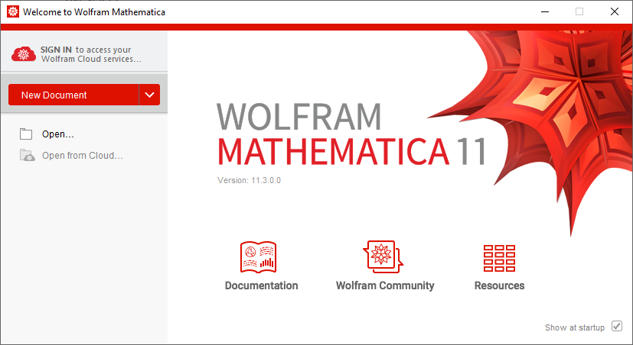

1. **Find the square root of 7**



1. **Find the value of Log (5,21)**

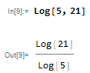

1. **Check if 5 is less than 2**

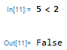

1. **Jfdnfk**

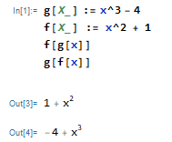

1. **dfsdf**

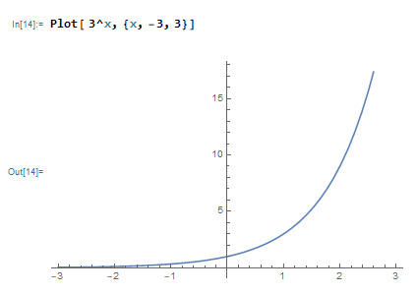

1. **rserserseraa**

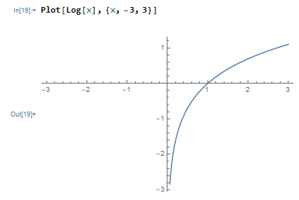

1. **fdfggf**

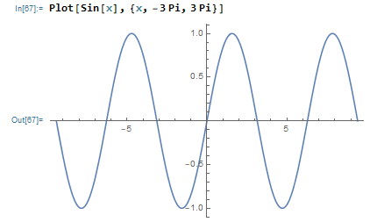

1. **ghfgh**

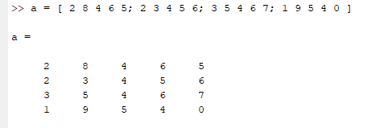

1. **gfdgkfdpgokf**

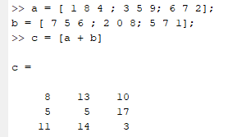

1. **Fgrgdr**

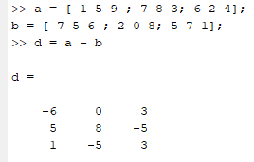

1. **Fkfnkf**

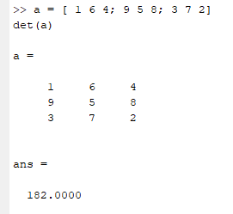

1. **Kdfhsfk**

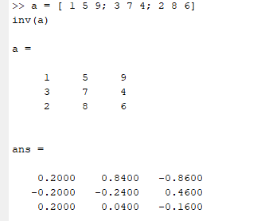

1. **Fsldfjsl**

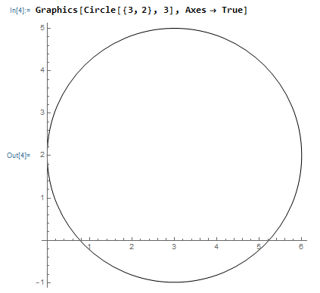

1. **Fgfgeg**

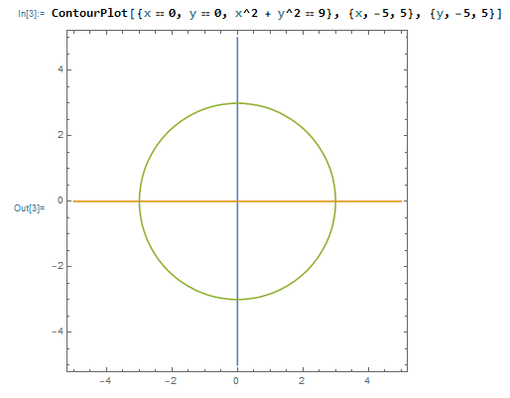

1. 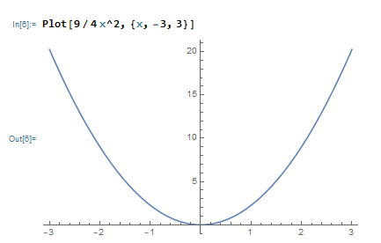 **Dfdfs**
2. **Fggfhsfhs**

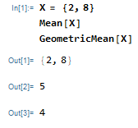

1. **Fkjwlf**

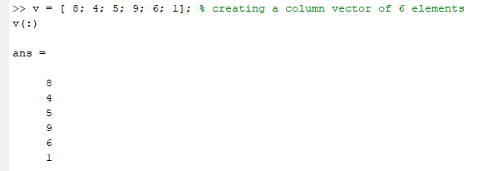

1. **Efewjf**

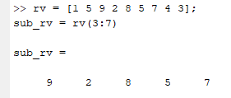

1. **Kjwljfo;elkfjw**

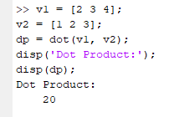

1. **Wkf;vkwkmv**

